**Scope Hands On Test CLO# 4**

Name ________________________________ Date ______________

**Scope 1**

Part 1: Connect the probe to the leads provided. Set the frequency and voltage below and have the instructor check it off. 50pts.

Frequency Hz __________________

Voltage RMS __________________

First attempt +50 _______________

Second attempt +30 ______________

Third attempt +10 _______________

Instructor signature _______

**Scope 2**

Part 2: Fill in the blanks below with the correct measurements for the given sine wave. Each blank is worth 10pts for a total of 50pts.

Volts / Div = 50 mV

Time / Div = 5 mSec

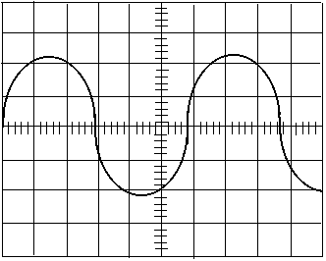

Time for 1 cycle = _________________ Frequency = ___________________

Voltage peak-peak (VPP)= ___________ Voltage peak (VP)= ______________

Voltage RMS (VRMS)= ______________

**Scope 3**

Part 2: Fill in the blanks below with the correct measurements for the given sine wave. Each blank is worth 10pts for a total of 50pts.

Volts / Div = 1 V

Time / Div = 20 mSec

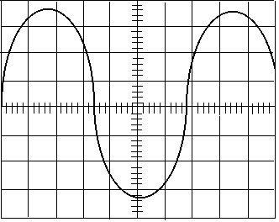

Time for 1 cycle = _________________ Frequency = ___________________

Voltage peak-peak (VPP)= ___________ Voltage peak (VP)= ______________

Voltage RMS (VRMS)= ______________